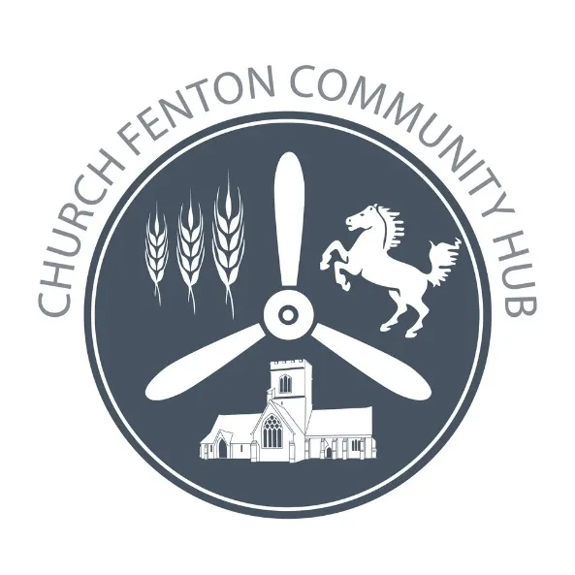

CHURCH FENTON COMMUNITY HUB LTD ANNUAL MEMBERS’ MEETING
Thursday, 30th November 2023 7.00pm in the Conservatory, The White Horse, Church Fenton.

MINUTES

Attendees: 12 Shareholders.

1. Welcome
The Chair, Nigel Thirkill, welcomed shareholders giving a summary of the past year.
To the year ended 30th June 2023 the Hub have: Held two ‘Warm Space’ lunches in the Village Hall in December and March.

Grant support totalling £1,200
Purchasing a further 2 Christmas lights for December 2022 (£600)

Grants for Fenton Fest in August 2022 & amp;amp; May 2023 (£300 each)

Commenced a Village History Project. This will be an ongoing project with input from members of the village who are able to provide historical knowledge of village events. It will also include current events that will become future history.

In the current year

Sponsorship has been awarded to the Bowling Club to provide shirts for match games.

The Pensioners Christmas Party will be held at the White Horse in December with food costs shared between the hub and The White Horse.

There are funds left from last years’ surplus to be allocated for grants.

Application forms are on the Hub website for grant requests.

Thanks were given to the Management Committee especially Sue Babbington who stood down as secretary in December. Sue had been secretary since the inception of the Hub and was instrumental in getting it off the ground.

2. Apologies for Absence. Received from 7 shareholders.

3. Minutes of last Annual Members Meeting.
Minutes of the meeting held on 3rd November 2022 were approved. Proposed: Sarah Hunt
Seconded: Paul Brooksby

4. Matters Arising There were no matters arising.

5. Report on the Society’s Performance and Annual Accounts.
A copy of the accounts had been circulated to shareholders prior to the meeting. It was unanimously agreed that these were a correct and true record.

6. Report on the state of membership
The secretary reported that there were currently 188 shareholders, 18 of which are minors.

7. Shareholder Interest Payments
The Management Committee proposed an interest payment of 2%. This was unanimously agreed by those present at the meeting.

8. Appointment of Auditors
Church Fenton Community Hub Management Committee retains the view that an audit is not required. It was proposed and unanimously agreed that our existing independent accountants Cadwallader &amp; Co will be retained for the coming year.

9. Proposal to adopt Plunkett Model Rules V 6
This item is on hold until clarification is received regarding the role position is clarified.

10. Management Committee Elections
In accordance with the Model Rules, one existing Management Committee member retired at the end of 2022/23.
One shareholder nomination was received.

The Management Committee for 2023/24 is:
Paul Brooksby; Sarah Chester; David Herbert Rebecca Hunt; Mandy Thirkill;
and Nigel Thirkill. Secretary Gwyneth Stephenson.

